


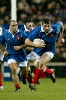
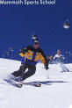


Les sports
Rugby | ●
Escrime | ●
Tennis | ●
Volley | ●
Hockey | ●
Ski | ●
Golf | ●

